Name :Swetha R Roll no:240701550

Familiar and Unfamiliar Navigation in UI/UX Design

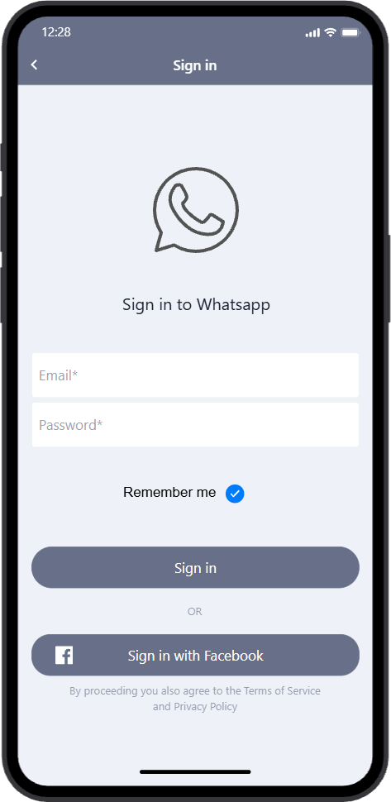

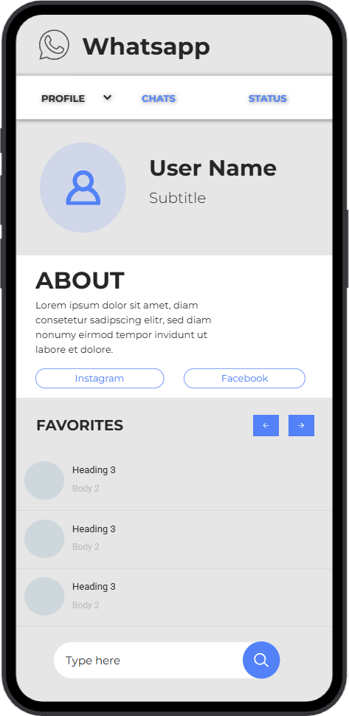

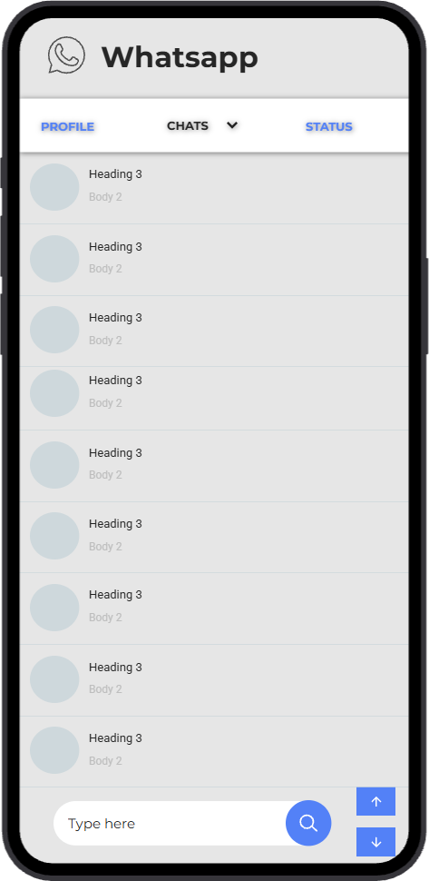

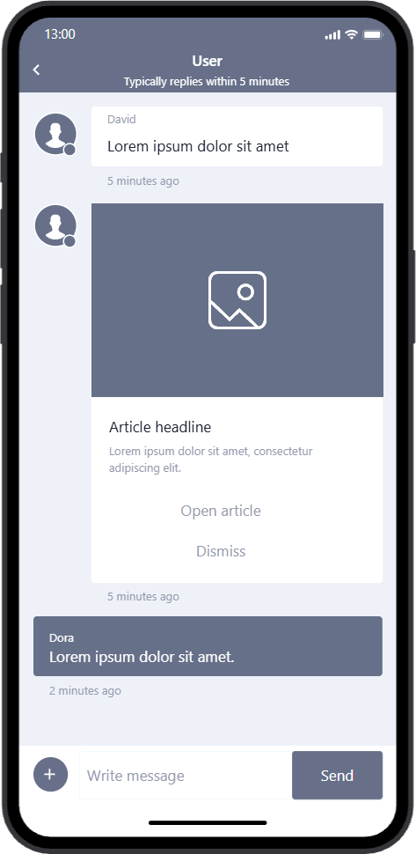

Here is a refined UI/UX design observation report analyzing the tension between familiar user mental models and unfamiliar navigation choices in the provided wireframes.

UI/UX Design Observation Report: Familiar vs. Unfamiliar Patterns
This report breaks down the provided mobile wireframes to evaluate how well they align with standard mobile design conventions, specifically highlighting where the interface leverages familiarity and where it introduces unfamiliar friction.

The Power of Familiarity (Working with Mental Models)
When users open a messaging app, they bring established expectations shaped by industry giants. These wireframes successfully utilize several familiar patterns that reduce the cognitive load for the user:
  - Authentication Flow (image_457c9a): The sign-in screen is highly standard. The centered logo, clear input fields for email/password, a "Remember me" toggle, and a
secondary "Sign in with Facebook" button follow established identity management patterns.
  - Chat Interface (image_457cf0): The conversation view successfully mimics standard
messaging apps. The use of left/right aligned chat bubbles to distinguish sender vs.
receiver, timestamp placement, and the bottom "Write message" input field are deeply familiar. The inclusion of an expanded "Article headline" card is also a well-executed standard for rich media previews.

The Introduction of Friction (Unfamiliar Patterns)
While the visual identity borrows heavily from WhatsApp, several navigational choices deviate significantly from standard mobile UX guidelines, creating potential usability issues:
  - Anti-Pattern: On-Screen Scroll Buttons: * In the "Favorites" section (image_457c5c), there are left/right arrow buttons.
    - In the "Chats" list (image_457cd1), there are up/down arrow buttons pinned to the bottom right.
    - The Issue: Mobile operating systems are inherently touch-first. Users intuitively swipe to scroll lists and carousels. Adding explicit tap targets for scrolling takes
up valuable screen real estate and feels clunky, breaking the natural fluidity of a mobile experience.

  - Misplaced Search/Input Bar: In both the Profile and Chat list views, a "Type here" bar with a floating action button (search icon) is anchored to the bottom. In standard mobile
design, bottom bars are reserved for either global navigation (tab bars) or direct messaging input. Placing a general search bar at the bottom of a list view is highly unfamiliar; users are trained to look for search functionality at the top of the screen just below the header.
  - Conflicting Navigation Hierarchy: The top tab bar contains "PROFILE," "CHATS,"
and "STATUS." However, "PROFILE" has a dropdown chevron next to it. Mixing a
top-level navigational tab with a dropdown menu creates ambiguity. It is unclear if tapping "PROFILE" switches the view or opens a sub-menu. Furthermore, profile settings are typically housed behind an avatar in the header or within a "Settings" tab, rather than taking up primary real estate alongside main messaging functions.

Actionable Recommendations for Proto.io Prototyping
To improve the usability of this prototype, consider the following adjustments:
- Embrace Native Scrolling: Remove the up/down and left/right arrow buttons. Set up the containers in Proto.io to be scrollable (vertical for chats, horizontal for favorites) to
mimic native touch gestures.
- Relocate Search: Move the search bar to the top of the "Chats" list, directly below the top navigation tabs.
- Clarify the Profile Architecture: Remove the dropdown chevron from the "Profile" tab if it is meant to act as a standard page switch. Alternatively, replace the "Profile" text tab
with a standard user avatar icon placed in the top-right corner of the app header to align with modern mobile standards.

